# **Agile Software Development Overview:**

Agile is a flexible and iterative approach to software development that emphasizes collaboration, customer feedback, and adaptability. Key components include:

1. **Iterative Development:** Work is divided into small, manageable increments called sprints (usually 1–4 weeks long).
2. **Collaboration:** Continuous communication between developers, stakeholders, and users.
3. **Adaptability:** Changes in requirements are welcomed, even late in the development cycle.
4. **Deliverables:** At the end of each sprint, a functional and testable product increment is delivered.
5. **Principles:**
   * Focus on delivering value.
   * Keep the process simple.
   * Prioritize individuals and interactions over processes and tools.

### Stages in Agile:

1. **Concept/Initiation:** Define the project scope and objectives.
2. **Sprint Planning:** Identify what can be achieved in the next sprint.
3. **Execution and Daily Meetings:** Develop and test features.
4. **Review and Retrospective:** Evaluate the sprint’s outcomes and plan for the next.

### Agile Model:

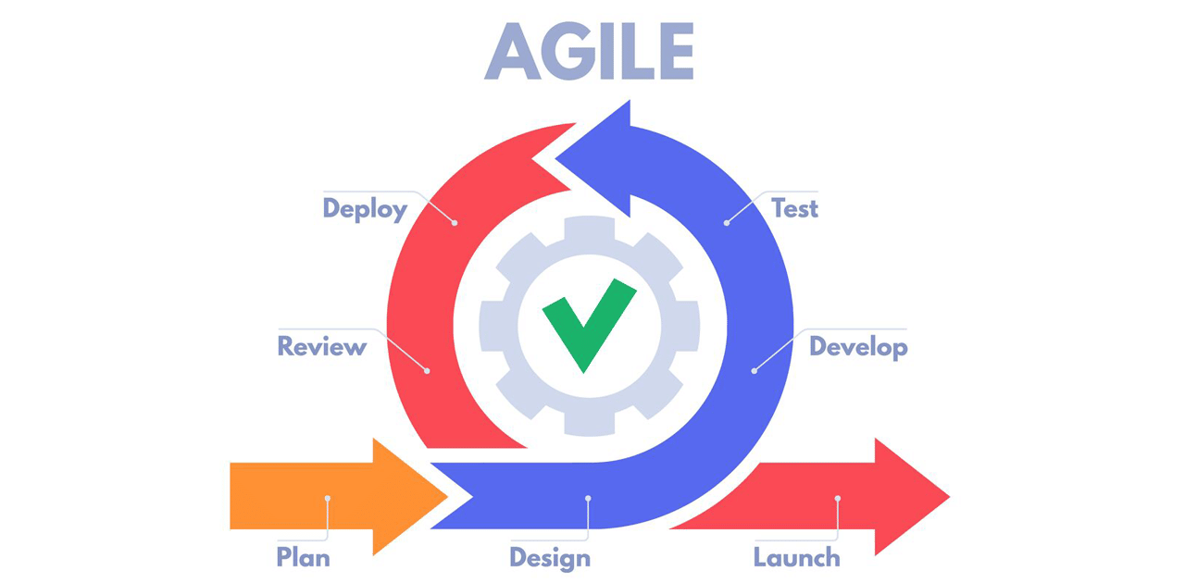

### Water Fall Model:

### Resources for a Deeper Dive:

1. [Agile Manifesto](https://agilemanifesto.org) – The foundational principles of Agile.
2. **Books:**
   * *Scrum: The Art of Doing Twice the Work in Half the Time* by Jeff Sutherland.
   * *Agile Estimating and Planning* by Mike Cohn.
3. **Online Courses:**
   * [Agile with Atlassian Jira (Coursera)](https://www.coursera.org/learn/agile-with-atlassian-jira).
   * [Introduction to Agile (LinkedIn Learning)](https://www.linkedin.com/learning/topics/agile).
4. **YouTube Videos:**
   * *Agile Development in 10 Minutes* by Simplilearn.
   * *What is Agile?* by Atlassian.

# **Project Development Plan:**

## Sprint 1 :

**First Sprint Goal: Build the Foundation**

**Duration:** 1–2 weeks  
**Objective:** Set up the project structure, understand software planning basics, and implement task creation and data storage.

**Sprint Tasks:**

**1. Project Setup (Day 1–2):**

* **Install necessary tools:**
  + ~~IDE for C++ development (e.g., Visual Studio or Code::Blocks).~~
  + ~~A beginner-friendly GUI framework like~~ [**~~Qt~~**](https://doc.qt.io/qt-6/qt-for-education.html) ~~or~~ [**~~wxWidgets~~**](https://www.wxwidgets.org/)~~.~~
* **Initialize Git Repository:**
  + ~~Set up the folder structure with directories for source code, resources, and saved data.~~
  + ~~Create a .gitignore file to exclude unnecessary files from commits.~~

**2. Task Management Basics (Day 3–5):**

* **Understand User Stories:**
  + Example: *"As a user, I want to create a task with a name and description so I can track its progress."*
* **Implement Core Functionality:**
  + ~~Write a simple console-based program to accept task names and descriptions.~~
  + ~~Save tasks to a local text file (backend logic).~~

**3. GUI Basics (Day 6–9):**

* **Learn GUI Framework Basics:**
  + Study how your chosen framework handles windows, buttons, and text fields.
* **Create the First GUI Screen:**
  + ~~Design a simple window with input fields for task name and description.~~
  + Add a "Save Task" button.

**4. Testing and Review (Day 10–12):**

* ~~Test the GUI and backend to ensure tasks are saved correctly.~~
* ~~Push changes to GitHub.~~
* Document what you’ve learned and challenges you faced.

**Why Choose wxWidgets Over Qt?**

1. **Simplicity and Lightweight**:
   * **wxWidgets** is often considered easier to use for beginners compared to Qt. It follows more closely to native OS look-and-feel, which means it tends to have a simpler setup and fewer abstractions.
   * It provides a more "native" experience for different operating systems, as it wraps native controls and doesn’t require you to learn a complex framework.
2. **Licensing**:
   * **wxWidgets** is open-source and more permissive under the LGPL license, which can be more suitable for certain projects if licensing is a concern.
   * **Qt** uses a more restrictive license, especially in its commercial versions, which could become a roadblock for projects that want to avoid licensing issues.
3. **Ease of Use**:
   * **wxWidgets** is often easier to get started with for small to medium-sized projects, especially for a beginner.
   * **Qt** is a bit more complex and designed for larger-scale, feature-rich applications. It comes with many advanced features that could add complexity to a simple project.

**Complexity Difference: wxWidgets vs Qt**

1. **Learning Curve**:
   * **wxWidgets** has a **gentler learning curve**, which makes it more beginner-friendly. It’s more intuitive for those who are just starting with GUI programming.
   * **Qt**, on the other hand, is **more feature-rich** and designed for more complex applications. The learning curve is steeper, but it comes with a broader set of tools for development (e.g., Qt Quick, QML for UI, etc.).
2. **Documentation and Community**:
   * **Qt** has more extensive documentation and a larger community, which can be helpful when you need advanced features.
   * **wxWidgets** has decent documentation but not as extensive as Qt’s, especially when it comes to more advanced topics.
3. **Advanced Features**:
   * **Qt** provides more built-in features for complex GUI elements, such as **animation, networking, and advanced graphics rendering**, which wxWidgets doesn't focus on as much. Qt is often preferred for **highly interactive or visually complex applications**.
   * **wxWidgets** focuses on being lightweight, so it doesn't have as many of the advanced features that Qt offers out-of-the-box.

**Will You Need to Change a Lot of Code to Transition from wxWidgets to Qt?**

1. **Fundamental Code Changes**:
   * **Yes**, transitioning from **wxWidgets to Qt will require significant changes in the code**.
   * **UI elements** (like buttons, panels, text fields, etc.) are handled differently in both frameworks. wxWidgets uses wxButton, wxTextCtrl, etc., while Qt uses QPushButton, QLineEdit, etc.
   * The **event handling mechanism** is different. wxWidgets uses event tables for event handling, whereas Qt uses **signals and slots** for event handling.
   * The **layout management** in both frameworks differs, so you'd have to rewrite how your GUI components are arranged.
2. **Code Reuse**:
   * There might be **some reusable logic** such as backend functions (for your streak tracking, database management, etc.), but the GUI code will largely need to be rewritten due to the differences in how the two frameworks structure and manage UI components.
3. **Transition Complexity**:
   * The transition complexity is **medium to high**, depending on how much of your application depends on the GUI. If your application has a very simple GUI, transitioning will be easier.
   * For more **complex GUI layouts**, the transition will require more work because of differences in layout management, widgets, and event handling.

**Summary: Should You Stick with wxWidgets or Switch to Qt?**

1. **Choose wxWidgets** if:
   * You are a beginner and need a framework that’s easier to learn.
   * You want a framework that’s simpler to use for small to medium-sized projects.
   * You prefer the licensing and open-source nature of wxWidgets.
   * You are aiming for a lightweight, simple application without a need for advanced features.
2. **Choose Qt** if:
   * You expect to build a more feature-rich, complex, or high-performance application.
   * You want advanced features like animations, better graphics support, and easier handling of complex UI elements.
   * You’re comfortable with a steeper learning curve and can handle the additional complexity for future scalability.

**In Conclusion:**

* **Transitioning from wxWidgets to Qt** will **require significant code changes**, especially in the GUI section (widgets, events, layouts, etc.).
* If you start with wxWidgets and later want to switch to Qt, the transition will not be trivial, but it's feasible if you design your project in a modular way, separating the core logic from the UI.
* **Qt** will offer more advanced features in the long term but at the cost of increased complexity, whereas **wxWidgets** will let you build your application faster and with less overhead.

If you’re aiming for a relatively simple project, wxWidgets will likely be a better starting point. You can always revisit Qt later if you need more advanced features.

**What Are User Stories?**

User stories are short, simple descriptions of a feature from the user's perspective. They are written in a way that explains *who* the user is, *what* they want to achieve, and *why* they want to achieve it. User stories are a fundamental part of Agile project management and help break down a project into manageable, user-focused tasks.

**Format of a User Story:**

**As a [type of user], I want [some goal] so that [reason].**

This format ensures that every feature is designed with the user's needs in mind.

### Your Project's User Stories

Based on your project's description, here are some possible user stories:

1. **Task Management**:

As a user, I want to create a task with a name and description so that I can track its progress.

1. **Streak Tracking**:

As a user, I want to track streaks for each task so that I stay motivated and maintain consistency.

1. **Reward System**:

As a user, I want to receive visual rewards when I reach certain milestones so that I feel accomplished and motivated.

1. **Task Validation (AI Feature for the Future)**:

As a user, I want the system to validate that I've completed a task (e.g., by answering questions or scanning images) so that the rewards feel meaningful.

1. **Local Data Storage**:

As a user, I want my tasks and streak data saved locally so that I can access them offline and keep track of my progress.

### Overview of File Handling in Python

1. **Opening Files**: Python provides the open() function, which allows you to open files in different modes:
   * "r": Read (default mode).
   * "w": Write (overwrites the file if it exists).
   * "x": Create a new file; raises an error if the file exists.
   * "a": Append to the file.
   * "b": Binary mode.
   * "t": Text mode (default).
   * Combine modes like "rb" for binary read.
2. **Reading Files**:
   * read(): Reads the entire file.
   * readline(): Reads one line at a time.
   * readlines(): Reads all lines and returns them as a list.
3. **Writing to Files**:
   * write(): Writes a string to the file.
   * writelines(): Writes a list of strings to the file.
4. **Closing Files**: Always close files with close() or use a with statement to manage files efficiently and avoid resource leaks.

### Recommended Resources

1. **W3Schools** offers an easy-to-follow tutorial covering the basics of file handling with examples on reading, writing, and appending to files. [Learn more on W3Schools](https://www.w3schools.com/python/python_file_handling.asp)​

[W3Schools.com](https://www.w3schools.com/python/python_file_handling.asp)

.

1. **FreeCodeCamp** has a detailed guide explaining file handling with examples of how to use read(), write(), and advanced concepts like seeking positions within files. Visit FreeCodeCamp's tutorial​

[FreeCodeCamp](https://www.freecodecamp.org/news/file-handling-in-python/)

.

1. **Programiz** is another beginner-friendly resource with clear explanations of different file handling modes and operations. Check out Programiz​

[Pynative](https://pynative.com/python/file-handling/)

.

1. **Real Python** offers a comprehensive tutorial with advanced topics like working with JSON files and file handling best practices. Explore Real PythonksforGeeks** covers a wide range of examples, including file manipulation, error handling during file operations, and file attributes. Read the GeeksforGeeks guide.

### JSON (JavaScript Object Notation)

JSON (JavaScript Object Notation) is a lightweight data-interchange format widely used for storing and exchanging data between systems, applications, and APIs. It is easy for humans to read and write and simple for machines to parse and generate. JSON is language-independent but uses conventions familiar to programmers of languages like C, C++, Java, Python, and JavaScript.

### Key Features of JSON

1. **Lightweight and Compact**: Unlike XML, JSON uses minimal formatting, making it more concise.
2. **Readable**: Its structure, similar to JavaScript objects, makes it easy for humans to understand.
3. **Easy to Parse**: Most programming languages have libraries or built-in support to parse JSON into objects or data structures.
4. **Data Representation**: Ideal for representing hierarchical data such as configurations or API responses.

### JSON Structure

JSON represents data as key-value pairs and supports:

* **Objects**: Encapsulated within {}, where each key is a string, and the value can be a string, number, boolean, array, object, or null.

json

Copy code

{

"name": "John",

"age": 30,

"isStudent": false

}

* **Arrays**: Ordered collections of values, enclosed in [].

json

Copy code

["Python", "JavaScript", "C++"]

### Use Cases

1. **Web APIs**: JSON is the standard for transmitting data between a client and server (e.g., RESTful APIs).
2. **Configurations**: Used for configuration files due to its simplicity (e.g., .eslintrc files in JavaScript projects).
3. **Data Storage**: Common in NoSQL databases like MongoDB.

### JSON vs Other Formats

* **JSON vs XML**: JSON is more lightweight and easier to read/write compared to XML.
* **JSON vs YAML**: YAML is more human-friendly but less strict and robust in parsing than JSON.

### Python and JSON

In Python, the json module provides functions to work with JSON:

* json.dump() and json.dumps() to convert Python objects to JSON.
* json.load() and json.loads() to parse JSON into Python objects.

Example:

python

Copy code

import json

# Convert Python dictionary to JSON

data = {"name": "Alice", "age": 25, "isStudent": True}

json_string = json.dumps(data)

print(json_string)

# Parse JSON back to Python dictionary

parsed_data = json.loads(json_string)

print(parsed_data)

### Resources for Learning JSON

1. [JSON Official Website](https://www.json.org)
2. [Python JSON Module Documentation](https://docs.python.org/3/library/json.html)
3. w3schools JSON Tutorial
4. [MDN Web Docs on JSON](https://developer.mozilla.org/en-US/docs/Web/JavaScript/Reference/Global_Objects/JSON)

• **JSON in Web Development**:

* What is JSON in API

• **JSON in Embedded Systems**:

* JSON for Embedded Systems and IoT

Let me know if you’d like guidance on working with JSON in Python!